23.3

Ventilation

 LEARNING OUTCOMES
After reading this section, you should be able to
- A.Describe the changes in alveolar pressure that are responsible for the movement of air into and out of the lungs.
- B.Explain how surfactant and pleural pressure prevent the collapse of the lungs and how changes in pleural pressure cause changes in alveolar volume.

Pressure Differences and Airflow
Ventilation is what we call breathing; it is the process of moving air into and out of the lungs. Airflow into the lungs requires a pressure gradient from the outside of the body to the alveoli. This pressure gradient is provided by atmospheric pressure—the combined force of all the gases that make up the air we breathe. Airflow from the lungs requires a pressure gradient in the opposite direction, which is created by the components of the respiratory system. The physics of airflow in tubes, such as the ones that make up the respiratory passages, is the same as that of the flow of blood in blood vessels (see chapter 21). Thus, the following relationships hold:
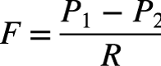
where F is airflow (milliliters per minute) in a tube, P1 is pressure at point 1, P2 is pressure at point 2, and R is resistance to airflow.
Air moves through tubes because of a pressure difference: Air moves from areas of higher pressure to areas of lower pressure. Thus, when P₁ is greater than P₂, gas flows from P₁ to P₂. The greater the pressure difference, the faster the flow rate. If the pressure difference decreases, the flow rate also decreases. For example, during inspiration, air pressure outside the body is greater than air pressure in the alveoli, and air flows into the body through the trachea and bronchi to the alveoli.

Pressure and Volume
The pressure of a gas in a container at a constant temperature follows Boyle’s law:
P = k/V
where P is gas pressure, k is a constant for a given temperature, and V is the volume of the container. Body temperature in humans can be considered a constant. Thus, Boyle’s law states that, in a container, such as the thoracic cavity or an alveolus, pressure is inversely proportional to volume. As volume increases, pressure decreases; as volume decreases, pressure increases (table 23.1).
Description | Importance
Boyle’s Law  The pressure of a gas is inversely proportional to its volume at a given temperature. | Air flows from areas of higher to lower pressure. When alveolar volume increases, causing pleural pressure to decrease below atmospheric pressure, air moves into the lungs. When alveolar volume decreases, causing pleural pressure to increase above atmospheric pressure, air moves out of the lungs.
Dalton’s Law  The partial pressure of a gas in a mixture of gases is the percentage of the gas in the mixture. | Gases move from areas of higher to lower partial pressure. The greater the difference in partial pressure between two points, the greater the rate of gas movement. Maintaining partial pressure differences ensures gas movement.
Henry’s Law  The concentration of a gas dissolved in a liquid is equal to the partial pressure of the gas times the solubility coefficient of the gas. | Only a small amount of the gases in air dissolves in the fluid lining the alveoli. Carbon dioxide, however, is 24 times more soluble than O₂; therefore, CO₂ exits through the respiratory membrane more readily than O₂ enters.
TABLE 23.1
Gas Laws

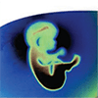Clinical IMPACT

Disorders That Decrease the Diameter of Air Passageways
The flow of air decreases when the resistance to airflow is increased by conditions that reduce the diameter of the respiratory passageways. According to Poiseuille’s law (see chapter 21), the resistance to airflow is proportional to the diameter (D) of a tube. Thus, a small change in diameter results in a large change in resistance, which greatly decreases airflow. For example, asthma results in the release of inflammatory chemicals, such as leukotrienes, that cause severe constriction of the bronchioles. Emphysema produces increased airway resistance because the bronchioles are obstructed as a result of inflammation and because damaged bronchioles collapse during expiration, thus trapping air within the alveoli. Cancer can also occlude respiratory passages as the tumor replaces lung tissue.
When there is increased resistance, increasing the pressure difference between alveoli and the atmosphere can help maintain airflow. Within limits, this can be accomplished by increased contraction of the muscles of respiration.

Airflow Into and Out of Alveoli
Because air movement is dependent on pressure gradients between the external environment and the lungs, pressure is measured with respiration-specific units. These measurements are used to describe Page 840airflow into and out of the lungs. Respiratory physiologists express different pressures within the respiratory system in the following ways:
- Barometric air pressure (PB), which is simply atmospheric air pressure outside the body, is designated as zero. Thus, whether at sea level with a pressure of 760 mm Hg or at 10,000 feet above sea level on a mountaintop with a pressure of 523 mm Hg, PB is always designated as zero.
- Respiratory pressures are measured relative to barometric air pressure. For example, intra-alveolar pressure (Palv) is the air pressure inside an alveolus. Because the pressure inside the alveolus measures approximately 759 mm Hg upon inhalation, P_{alv} is usually expressed as −1 mm Hg.This is because it has decreased by 1 mm Hg below PB. Then, when you exhale, the P_{alv} increases to about 761 mm Hg, so it is usually designated as +1 mm Hg. Thus, for simplicity, P_{alv} is always given as its difference from P_{B}—either 1 mm Hg above P_{B} or 1 mm Hg below P_{B}.
The movement of air into and out of the lungs results from changes in thoracic volume, which cause changes in alveolar volume. The changes in alveolar volume produce changes in intra-alveolar pressure. The pressure difference between barometric air pressure and intra-alveolar pressure (PB− Palv) results in air movement. The details of this process during quiet resting breathing are as follows:
- End of expiration (figure 23.13, step 1). By the end of expiration, barometric air pressure and intra-alveolar pressure are equal. Therefore, no air moves into or out of the lungs.
- During inspiration (figure 23.13, step 2). As inspiration begins, contraction of inspiratory muscles increases thoracic volume, which results in expansion of the lungs and an increase in alveolar volume (see the section “Changing Alveolar Volume”). The increased alveolar volume causes a decrease in intra-alveolar pressure below barometric air pressure to approximately −1 mm Hg. Air flows into the lungs because barometric air pressure is greater than intra-alveolar pressure.
- End of inspiration (figure 23.13, step 3). At the end of inspiration, the thorax stops expanding, the alveoli stop expanding, and intra-alveolar pressure becomes equal to barometric air pressure because of airflow into the lungs. No movement of air occurs after intra-alveolar pressure becomes equal to barometric pressure, but the volume of the lungs is larger than at the end of expiration.
- During expiration (figure 23.13, step 4). During expiration, the volume of the thorax decreases as the diaphragm relaxes, and the thorax and lungs recoil. Because thoracic volume determines alveolar volume, the smaller thoracic volume results in a corresponding decrease in alveolar volume. Thus, intra-alveolar pressure rises over barometric air pressure to approximately +1 mm Hg. Because intra-alveolar pressure is greater than barometric air pressure, air flows out of the lungs. As expiration ends, the decrease in thoracic volume stops, and the alveoli stop changing size. The process repeats, beginning at step 1.
Alveolar pressure changes during respiration
FUNDAMENTAL Figure
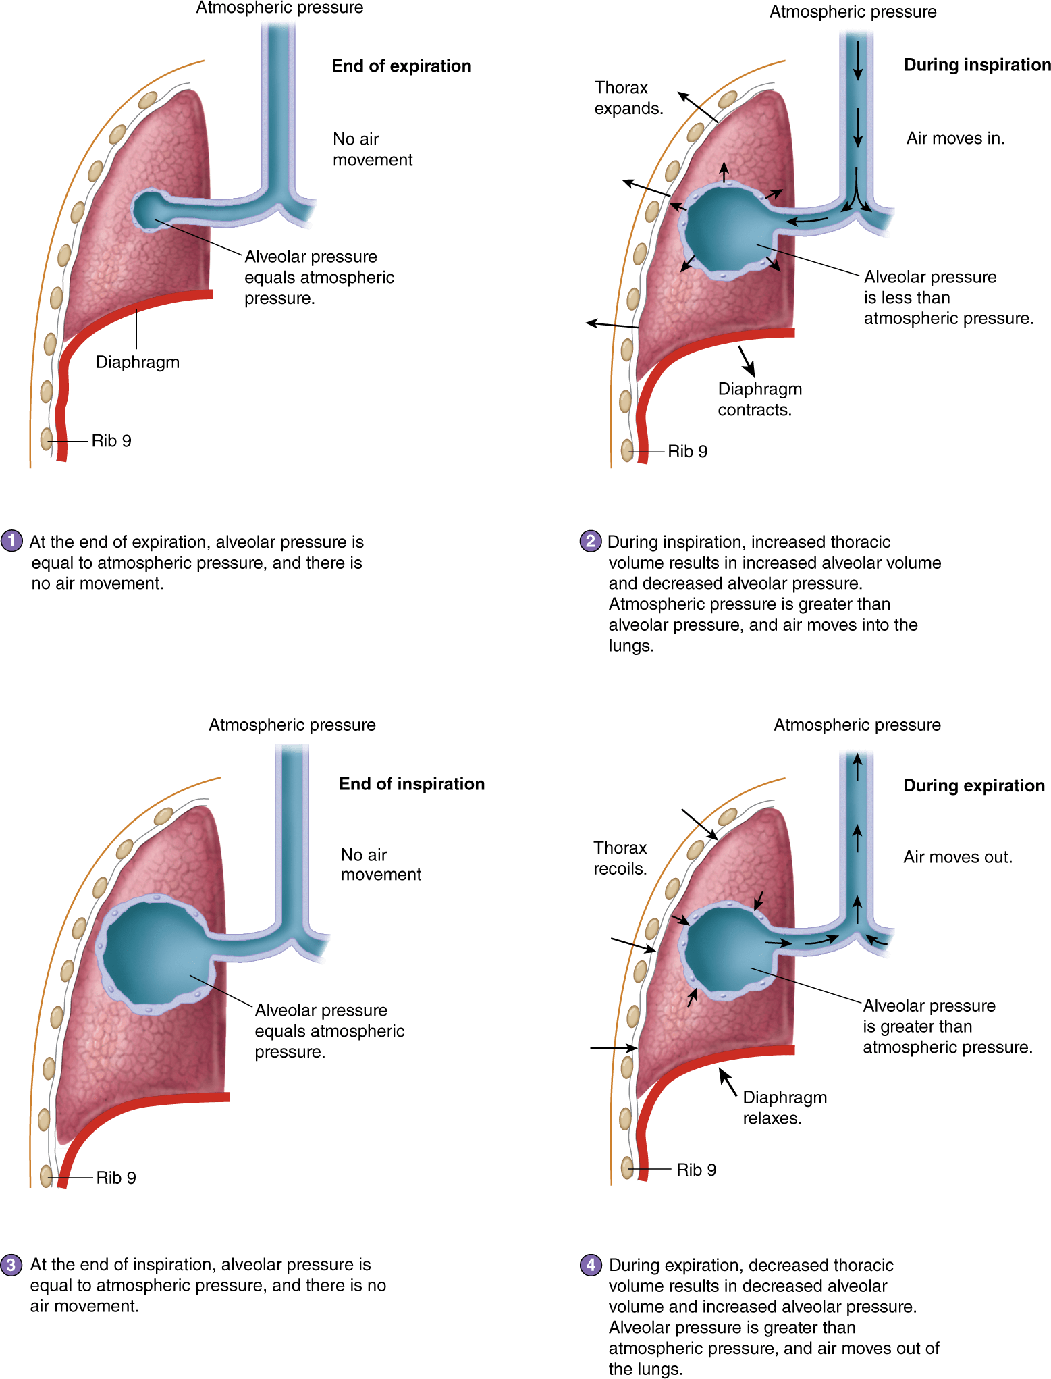PROCESS FIGURE 23.13 Intra-alveolar Pressure Changes During Inspiration and Expiration
The combined space of all the alveoli is represented by a large “bubble” (blue). The alveoli are actually microscopic and would not be visible at the scale of this illustration. 
APR Module 11 Respiratory: Animation: Alveolar pressure Changes

ASSESS YOUR PROGRESS
- 23.What is ventilation?
- 24.How do pressure differences and resistance affect airflow through a tube?
- 25.What happens to the pressure within a container when the volume of the container increases? Whose law describes this relationship?
- 26.What are the assigned values for barometric air pressure and for intra-alveolar pressure?
- 27.Describe the process of making intra-alveolar pressure changes that occurs during quiet resting breathing.

Changing Alveolar Volume
It is important to understand that lung recoil and changes in pleural pressure cause changes in alveolar volume. When alveolar volume changes, it causes the pressure differences between the environment and the alveoli, resulting in ventilation.

Lung Recoil
One factor that changes alveolar volume is lung recoil. This is the tendency for the lungs to decrease in size after they are stretched. Imagine a stretched rubber band snapping back to its original size when released. Similarly, upon expiration, the tension on the lungs is released and they shrink. This compresses the alveoli and reduces their volume. Expanded alveoli decrease in size for two reasons: (1) elastic recoil caused by the elastic fibers in the alveolar walls and (2) surface tension of the film of fluid that lines the alveoli. Surface tension occurs due to the tendency of hydrogen bonding of water molecules with each other. Water molecules are all attracted to the center of an alveolus and form a drop of water.Because the alveolar fluid water molecules are also attracted to the surface of the alveoli, formation of a drop of water causes the alveoli to collapse, thus producing fluid-filled alveoli with smaller volumes than air-filled alveoli.
A molecule called surfactant (ser-fak′tănt; surface acting agent) forms a one-molecule-thick layer over the alveolar fluid, which reduces the surface tension in the alveoli. Surfactant is a mixture of lipoprotein molecules produced by the type II pneumocytes of the alveolar epithelium. With surfactant, the force produced by surface tension is approximately 3 mm Hg; without surfactant, the force can be as high as 30 mm Hg. Thus, surfactant greatly reduces the tendency of the lungs to collapse. Premature infants do not produce enough surfactant. This is what is meant by the idea that “their lungs are immature” (see Clinical Impact, “Infant Respiratory Distress Syndrome”).

Pleural Pressure
Another factor important in air movement into and out of the lungs is the pressure within the pleural cavity, called pleural pressure (Ppl). Recall that the visceral pleura and the parietal pleura are adhered to each other, so that when the thoracic cavity expands, the lungs are “pulled” outward. This creates a negative pressure in the pleural cavity. Because pleural pressure is normally less than intra-alveolar pressure, alveoli can expand. In order for the lungs to function normally, alveoli at rest need to be partially expanded. If not, the alveoli completely collapse, making it very difficult to re-expand them.
Page 841
Page 842

Clinical IMPACT

Infant Respiratory Distress Syndrome
Infant respiratory distress syndrome is common in premature infants, especially those with a gestation age of less than 7 months. This condition occurs because surfactant is not produced in adequate quantities until approximately 7 months of development. Thereafter, the amount produced increases as the fetus matures. Pregnant women who are likely to deliver prematurely can be given cortisol, which crosses the placenta into the fetus and stimulates surfactant synthesis.
If a newborn produces insufficient surfactant, the lungs tend to collapse. Thus, the muscles of respiration must exert a great deal of energy to keep the lungs inflated, and even then ventilation is inadequate. Without specialized treatment, most babies with this disease die soon after birth as a result of inadequate ventilation of the lungs and fatigued respiratory muscles. Infants with infant respiratory distress syndrome are treated with pressurized air, which delivers oxygen-rich air to the lungs. The pressure helps keep the alveoli inflated. In addition, surfactant administered with the pressurized air can reduce surface tension in the alveoli. Surfactant can be obtained from cow, pig, and human lungs; from human amniotic fluid; or from genetically modified bacteria. Synthetic surfactant is also available.
If you have flown on a plane, or have been to the mountains, you may have experienced a situation similar to that which keeps the alveoli expanded. At higher altitudes, the atmospheric pressure is much lower than at sea level. If a bottle of liquid (such as shampoo), normally kept at sea level, is rapidly taken to a high altitude, it will “explode.” Because there is not as much force on the outside of the bottle at high altitude, it expands. Similarly, because the pleural pressure pulls the pleura away from the outside of the alveoli, the pressure on the alveoli is lower. The lower pressure allows the alveoli to expand.
Even after exhaling, pleural pressure is lower than intra-alveolar pressure. At the end of a normal expiration, pleural pressure is −4 mm Hg, and intra-alveolar pressure is 0 mm Hg. This is due to a suction effect caused by fluid removal by the lymphatic system and by lung recoil. As the lungs recoil, the visceral pleura is pulled against the parietal pleura. Normally, the visceral pleura will not pull away from the parietal pleura because pleural fluid holds them together. Nonetheless, this pull decreases pressure in the pleural cavity, an effect that can be appreciated by putting water on the palms of your hands and then placing them together. As you gently pull your hands apart, you will feel a sensation of negative pressure.
Transpulmonary pressure is the difference between intra-alveolar pressure and pleural pressure. When pleural pressure is lower than intra-alveolar pressure, the alveoli tend to expand. However, they do not expand to the point of bursting because the lungs’ tendency to recoil places an opposite force on alveolar expansion. Therefore, the alveoli expand when the pull of the visceral pleura against the parietal pleura is stronger than the opposite pull of lung recoil. In other words, when the transpulmonary pressure is around 4 mm Hg, the alveoli are expanded.
However, if the transpulmonary pressure decreases, the alveoli collapse. This happens when the two pleural membranes become separated and the force from lung recoil is strong enough to pull the visceral pleura away from the parietal pleura. Specifically, pleural pressure increases and becomes equal to barometric air pressure. This happens when the thoracic wall or lung is pierced, and the pleural cavity opens to the outside.Therefore, the alveoli collapse, lung recoil is unopposed, and the entire lung collapses and pulls away from the thoracic wall. Because the two pleural cavities are independent, one lung can collapse while the other remains inflated.
This pleural pressure increase is called a pneumothorax. A pneumothorax occurs when the parietal pleura is pierced or torn. Air then enters the pleural cavity through the damaged parietal pleura. A pneumothorax has two major possible causes: penetrating trauma and nonpenetrating trauma. Types of penetrating traumas include being stabbed, getting shot by a gun, and breaking a rib. Types of nonpenetrating traumas include a blow to the chest; a medical procedure, such as insertion of a catheter to withdraw pleural fluid; disease, such as an infection or emphysema; and severe, spastic coughing.
The most common symptoms of a pneumothorax are chest pain and shortness of breath. Treatment depends on the cause and severity. In patients with mild symptoms, the pneumothorax may resolve on its own. In other cases, a chest tube that aspirates the pleural cavity and restores a negative pressure can cause reexpansion of the lung. Surgery may also be necessary to close the opening into the pleural cavity.
In a tension pneumothorax, the pressure within the pleural cavity is always higher than barometric air pressure. Any situation where a pneumothorax occurred can lead to a tension pneumothorax. If a tear in the pleural cavity forms a tissue flap that acts as a flutter valve, it will allow air to enter the pleural cavity during inspiration but will not allow it to exit during expiration. The result is an increase in air and pressure within the pleural cavity, which can compress blood vessels returning blood to the heart, causing decreased venous return, low blood pressure, and inadequate delivery of O₂ to tissues. The insertion of a large-bore needle into the pleural cavity allows air to escape and releases the pressure.

Pressure Changes During Inspiration and Expiration
At the end of a normal expiration, pleural pressure is −4 mm Hg, and intra-alveolar pressure is equal to barometric pressure (0 mm Hg). During normal, quiet inspiration, pleural pressure decreases to −7 mm Hg (figure 23.14, step 1). Consequently, the alveolar volume increases, intra-alveolar pressure decreases below barometric air pressure, and air flows into the lungs. As air flows into the lungs, intra-alveolar pressure increases and becomes equal to barometric pressure at the end of inspiration (figure 23.14, steps 2 and 3).
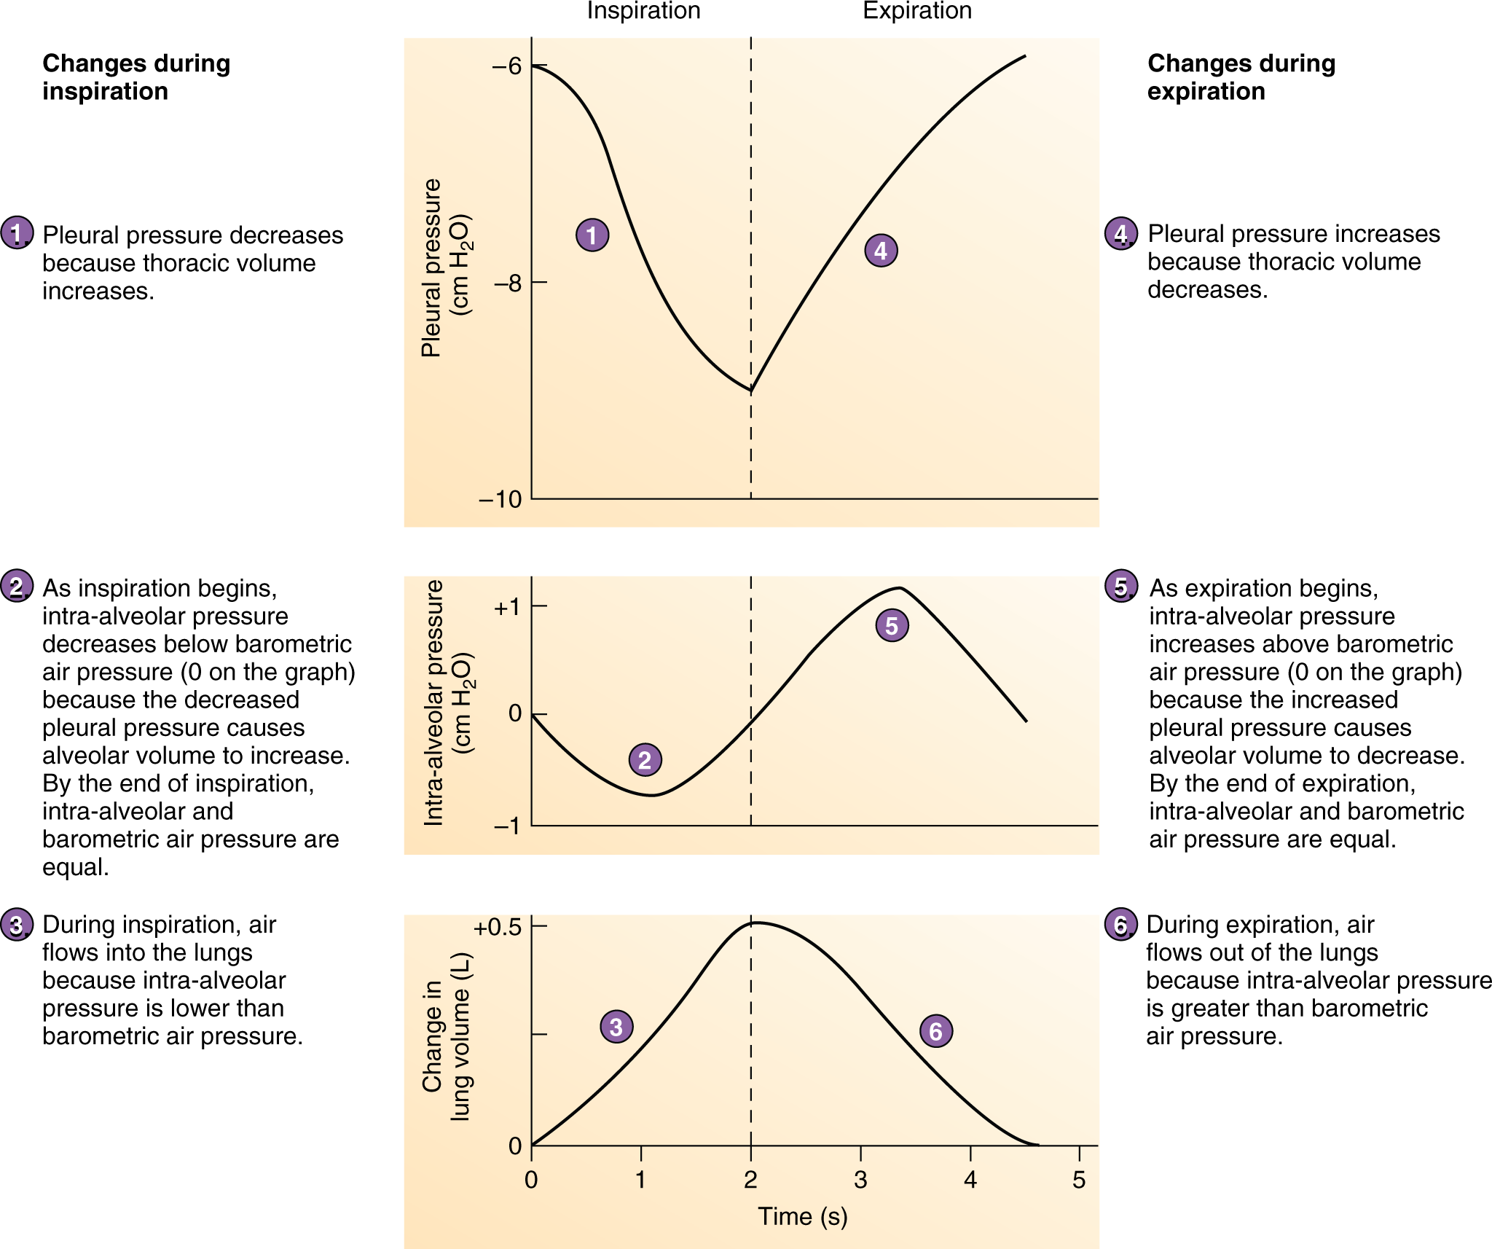PROCESS FIGURE 23.14 Dynamics of a Normal Breathing Cycle
The decrease in pleural pressure during inspiration occurs for two reasons. First, because changing volume affects pressure (Boyle’s law), the increased volume of the thoracic cavity causes decreased pleural pressure. Second, as the thoracic cavity expands, the lungs expand because they adhere to the inner thoracic wall through the pleurae. As the lungs expand, their tendency to recoil Page 843increases, resulting in an increased suction effect and a lowering of pleural pressure. The tendency for the lungs to recoil increases as the lungs are stretched, similar to the increased force generated in a stretched rubber band.
During expiration, pleural pressure increases because of decreased thoracic volume and decreased lung recoil (figure 23.14, step 4). As pleural pressure increases, alveolar volume decreases, intra-alveolar pressure increases above barometric air pressure, and air flows out of the lungs. As air flows out of the lungs, intra-alveolar pressure decreases and becomes equal to barometric pressure at the end of expiration (figure 23.14, steps 5and 6).

ASSESS YOUR PROGRESS
- 28.What is lung recoil, and what two factors cause it?
- 29.How does surfactant reduce lung recoil? What happens if the alveoli have insufficient surfactant?
- 30.What is pleural pressure? What happens to alveolar volume when pleural pressure decreases? What causes pleural pressure to be lower than intra-alveolar pressure?
- 31.How does a pneumothorax cause a lung to collapse? How does a pneumothorax affect the chest cavity?
- 32.During inspiration, what causes pleural pressure to decrease? What effect does this have on intra-alveolar pressure and air movement?
- 33.During expiration, what causes pleural pressure to increase? What effect does this have on intra-alveolar pressure and air movement?

23.4

Measurement of Lung Function

LEARNING OUTCOMES
After reading this section, you should be able to
- A.Define compliance, minute volume, and alveolar ventilation.
- B.List the pulmonary volumes and capacities, and define each of them.
- C.Distinguish between anatomical dead space and physiological dead space.
Sometimes, the amount of air a person’s lungs are capable of moving is not sufficient to support normal activities. In that case, several types of medical tests can be performed to determine what Page 844might be causing the lung malfunction. The patient’s measurements are then used to diagnose specific diseases and to track recovery.

Compliance of the Lungs and Thorax
Compliance is a measure of the ease with which the lungs and thorax expand. The compliance of the lungs and thorax is the volume by which they increase for each unit of change in intra-alveolar pressure. It is usually expressed in liters (volume of air) per mm Hg (pressure), and for a normal person the compliance of the lungs and thorax is 0.18 L/mm Hg. That is, for every 1 mm Hg change in intra-alveolar pressure, the volume changes by 0.18 L.
A lower than normal compliance means that it is harder to expand the lungs and thorax. There are many conditions that could decrease compliance. These include the deposition of inelastic fibers in lung tissue (pulmonary fibrosis), the collapse of the alveoli (infant respiratory distress syndrome and pulmonary edema), increased resistance to airflow caused by airway obstruction (asthma, bronchitis, and lung cancer), and deformities of the thoracic wall that reduce its ability to expand and allow the thoracic volume to increase (kyphosis and scoliosis). Pulmonary diseases that result in decreased compliance can markedly affect the total amount of energy required for ventilation and increase the total amount of energy expended by the body by up to 30%.
On the other hand, if the lungs and thorax have lost some of their elasticity, the compliance will be greater. If this becomes the case, it is easier to expand the lungs and thorax. For example, emphysema sometimes causes the destruction of elastic lung tissue. This reduces the elastic recoil force of the lungs, thereby making expansion of the lungs easier and resulting in a higher than normal compliance.

Pulmonary Volumes and Capacities
Spirometry (spī-rom′ĕ-trē) is the process of measuring volumes of air that move into and out of the respiratory system, and a spirometer(spī-rom′ĕ-ter) is the device used to measure these pulmonary volumes. The four pulmonary volumes and representative values for a young adult male are graphed in figure 23.15 and listed here:
- Tidal volume is the normal volume of air inspired and expired with each breath. At rest, quiet breathing results in a tidal volume of approximately 500 mL.
- Inspiratory reserve volume is the amount of air that can be inspired forcefully after a normal inspiration (approximately 3000 mL at rest).
- Expiratory reserve volume is the amount of air that can be forcefully expired after a normal expiration (approximately 1100 mL at rest).
- Residual volume is the volume of air still remaining in the respiratory passages and lungs after the most forceful expiration (approximately 1200 mL).
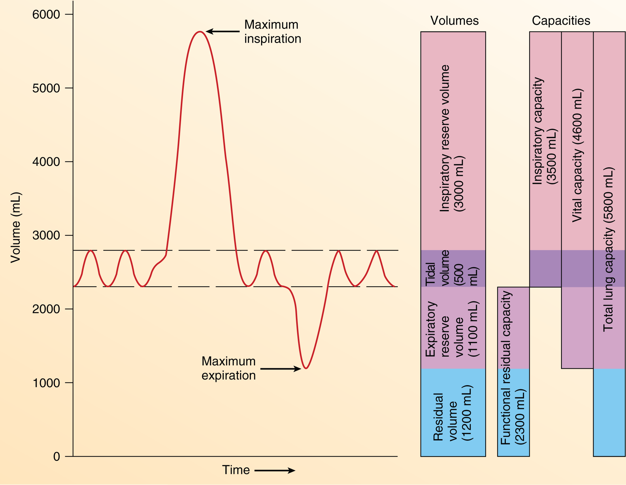FIGURE 23.15 Lung Volumes and Lung Capacities
The tidal volume during resting conditions is represented.
The tidal volume increases when a person is more active. Because the maximum volume of the respiratory system does not change from moment to moment, an increase in tidal volume causes a decrease in the inspiratory and expiratory reserve volumes.
Pulmonary capacities are the sum of two or more pulmonary volumes (figure 23.15). Some pulmonary capacities follow:
- Inspiratory capacity is the tidal volume plus the inspiratory reserve volume. It is the amount of air a person can inspire maximally after a normal expiration (approximately 3500 mL at rest).
- Functional residual capacity is the expiratory reserve volume plus the residual volume. It is the amount of air remaining Page 845in the lungs at the end of a normal expiration (approximately 2300 mL at rest).
- Vital capacity is the sum of the inspiratory reserve volume, the tidal volume, and the expiratory reserve volume. It is the maximum volume of air a person can expel from the respiratory tract after a maximum inspiration (approximately 4600 mL).
- Total lung capacity is the sum of the inspiratory and expiratory reserve volumes plus the tidal volume and the residual volume (approximately 5800 mL).
Factors such as gender, age, body size, and physical conditioning cause variations in respiratory volumes and capacities from one individual to another. For example, the vital capacity of adult females is usually 20–25% less than that of adult males. The vital capacity reaches its maximum amount in young adults and gradually decreases in the elderly. Tall people usually have a greater vital capacity than short people, and thin people have a greater vital capacity than obese people. Well-trained athletes can have a vital capacity 30–40% above that of untrained people. In patients whose respiratory muscles are paralyzed by spinal cord injury or diseases such as poliomyelitis or muscular dystrophy, vital capacity can be reduced to values not consistent with survival (less than 500–1000 mL). Factors that reduce compliance also reduce vital capacity.
The forced expiratory vital capacity is a simple and clinically important pulmonary test. The patient inspires maximally and then exhales maximally into a spirometer as rapidly as possible. The volume of air expired at the end of the test is the vital capacity. The spirometer also records the volume of air expired per second. The forced expiratory volume in 1 second (FEV1) is the amount of air expired within the first second of the test. In some conditions, the vital capacity may not be dramatically affected, but how rapidly air is expired can be greatly decreased. Airway obstruction, caused by asthma, the collapse of bronchi in emphysema, or a tumor, as well as disorders that reduce the ability of the lungs or chest wall to deflate, such as pulmonary fibrosis, silicosis, kyphosis, and scoliosis, can cause a decreased FEV₁.

Minute Volume and Alveolar Ventilation
A common vital sign measured in clinics and hospitals is the respiratory rate, or number of breaths per minute. The volume of air moved through the respiratory system per minute is the minute volume. The minute volume equals the tidal volume times the respiratory rate. Using approximate numbers, we can calculate the average minute volume. With a resting tidal volume of 500 mL and a respiratory rate of 12 breaths per minute, minute volume averages approximately 6 L/min (500 mL x 12 breaths/min = 6000 mL/min, or 6 L/min).
Although minute volume measures the amount of air moving into and out of the respiratory system per minute, it is not a measure of the amount of air available for gas exchange. However, minute volume is clinically important because it is an indication of CO₂ levels, an important physiological parameter (see section 23.6).
A more accurate measure of the amount of air available for gas exchange per minute is alveolar ventilation. In order to calculate alveolar ventilation, we must first account for a parameter called the dead space. The structures of the respiratory system where gas exchange does not take place are collectively called the dead space: anatomical dead space and physiological dead space. Anatomical dead space is generally about 1 mL of dead space per pound of an individual’s “ideal” body weight. It includes the nasal cavity, pharynx, larynx, trachea, bronchi, bronchioles, and terminal bronchioles. Physiological dead space is the anatomical dead space plus the volume of any alveoli in which gas exchange is less than normal. In a healthy person, anatomical and physiological dead spaces are nearly the same, meaning that most alveoli are functional. However, in patients with emphysema, alveolar walls degenerate, and small alveoli combine to form larger alveoli. The result is not only fewer alveoli but also alveoli with an increased volume and decreased surface area. Although the enlarged alveoli are still ventilated, their surface area is inadequate for complete gas exchange, and the physiological dead space increases.
During inspiration, much of the inspired air fills the dead space first before reaching the alveoli and, thus, is unavailable for gas exchange. The volume of air available for gas exchange per minute is called alveolar ventilation 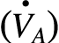, and it is calculated as follows:
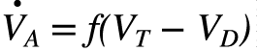[D]
where  is alveolar ventilation (milliliters per minute), f is respiratory rate (frequency; breaths per minute), V_{T} is tidal volume (milliliters per respiration), and V_{D} is dead space (milliliters per respiration). The dot over the letter V means that this is a per minute measure. Thus, for each breath, physiologically relevant air is only that volume inside healthy alveoli.

Predict 5
What is the alveolar ventilation of a resting person with a tidal volume of 500 mL, a dead space of 150 mL, and a respiratory rate of 12 breaths per minute? Suppose the person exercises, so that tidal volume increases to 4000 mL, dead space increases to 300 mL due to dilation of the respiratory passageways, and respiratory rate increases to 24 breaths per minute. What is the alveolar ventilation then? How is the change in alveolar ventilation beneficial for doing exercise?
Answer

ASSESS YOUR PROGRESS
- 34.What is compliance? What is the effect on lung expansion when compliance increases or decreases?
- 35.Distinguish among tidal volume, inspiratory reserve volume, expiratory reserve volume, and residual volume.
- 36.Differentiate among inspiratory capacity, functional residual capacity, vital capacity, and total lung capacity.
- 37.What is forced expiratory volume in 1 second, and why it is clinically important?
- 38.What is the difference between minute volume and alveolar ventilation?
- 39.What is dead space? Contrast anatomical dead space with physiological dead space.

